Executive Summary
In present state, rIXD Receive Dock teams utilize IDRT to virtually move pallets shipped from nIXD from the shipment manifest to a drop zone on site, which also confirms which pallets physically arrived on site and provides improved visibility for all Transfer In (TI) pallets being processed through the facility. However, IDRT is currently unable to take as inputs the paX labels applied to New Vendor Freight (NVF) pallets via IMTP, as these paX are applied pre-receive.

This presents a barrier in the conversion of Inbound waterspiders to the rated IDRT function. A pilot was conducted In Q1 2025 to measure the impact of this type of conversion for Outbound waterspiders to Pallet Movement that resulted in a 57.7% rate increase post-conversion due to newly available associate productivity data. The entitlement based on the Inbound waterspider conversion achieving the same rate improvement is $30.7MM.

Outbound Waterspider Indirect Conversion Pilot
From Week 49 to Week 3, a pilot was conducted at SWF2 to modify to standard work for waterspiders on Outbound Dock. Waterspiders were directed to utilize a hand scanner to move pallets to staging areas using the “Move Container” function, which changed their labor tracking from Transfer Out Dock -> EOL Waterspider (indirect) to Transfer Out Dock -> Pallet Movement (direct). Modifying their labor tracking in this manner gave Outbound Dock leadership visibility into associate rates and a mechanism for entering idle time feedbacks for applicable associates.
Rates for these associates increased from by 57.7% during the pilot (Appendix B). Additionally during the same time frame, the following Quality wins materialized:
- Dwelling Inventory Over Threshold (DIOT) was reduced by 77.9% (Appendix C).
- Inventory in Odd Locations (IOL) Over Threshold was reduced by 96.2% (Appendix D).
- Unexpected Container Overages (UCO) was reduced by 36.8% (Appendix E).

Inbound Waterspider Indirect Conversion
A similar conversion is being planned for Receive Dock waterspider standard work. Within existing standard work, waterspider associates on the inbound dock are fully indirect, and they are utilized to move both NVF and TI freight either to nearby conveyance to be depalletized or directly to staging areas on the Outbound Dock (pallet received freight). In present state, it is important to note that receive dock leadership does not distinguish between waterspiders in each role because the mix of pallet received freight and depalletized freight is variable – associates are expected to complete both types of physical moves as needed.
The proposed standard work change is to convert the movement of received pallets to a direct function using SAM (Transfer Out Dock -> Pallet Movement) and to convert the movement of depalletize-bound pallets to a direct function using IDRT (RSR Support -> IDRT).
According to staffing models reported by rIXD sites in October 2024 (Appendix F), rIXD currently staffs a minimum of 314 waterspiders across all 27 sites included in the report. If the 57.7% rate improvement is repeated following the conversion of waterspiders to direct functions, the projected savings will be $30.7MM.

Required Change
To roll out revised standard work that will allow for Receive Dock waterspider headcount to be converted to direct a direct function, IDRT will need to be updated to accept as inputs paX labels being scanned during the NVF receive process (IMTP) prior to receive.

Appendix
Appendix A: rIXD Big Box Receive Data Week 14
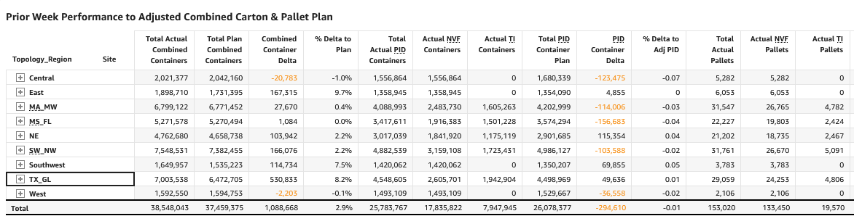
Appendix B: SWF2 Pallet Movement Rates Week 49 to Week 3

Appendix C: SWF2 DIOT Week 49 to Week 3

Appendix D: SWF2 IOL Over Threshold Week 49 to Week 3

Appendix E: SWF2 UCO Week 49 to Week 3

Appendix F: Inbound Dock Waterspider MSMs reported by rIXD sites October 2024.
Site | IBD WS MSM
LAX9 | 13
LAS1 | 10
ONT8 | 11
SCK4 | 14
SMF3 | 11
VGT2 | 17
FTW1 | 12
GYR2 | 11
GYR3 | 12
IAH3 | 13
IND9 | 12
MDW2 | 12
RFD2 | 12
ABE8 | 14
AVP1 | 12
CLT2 | 10
FWA4 | 10
RMN3 | 10
SWF2 | 14
TEB9 | 12
ORF2 | 10
LGB8 | 8
MEM1 | 15
MQJ1 | 14
RDU2 | 12
LGB8 | 8
SBD1 | 5
rIXD | 314

Appendix G: Projected lift of Inbound Waterspider Direct Conversion
Current Headcount | Rate Increase % | Headcount Reduction % | Reduced Headcount | Runtime / Year (Hours) | Fully Burdened Wage Rate Q1 2025 | Projected Savings
314 | 57.70% | 36.60% | 114.924 | 7300 | $ 36.63 | $ 30,730,562.68

